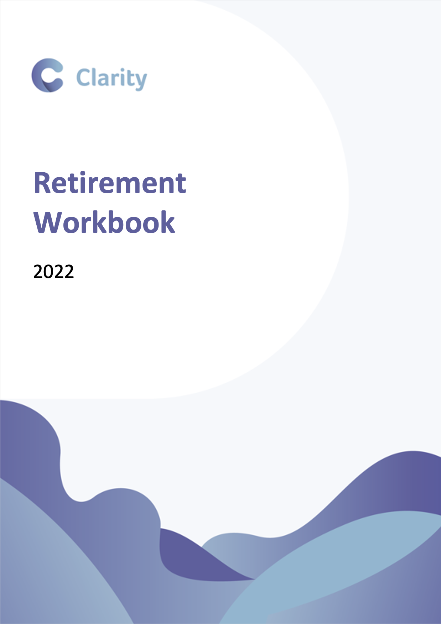
Step 1 - What does retirement look like to you

Start to think about how your retirement would look in an ideal world. If you have a partner have a chat with them and get their thoughts too. Then once you have some initial ideas, start to jot them down.

 | Partner 1 | Partner 2
When do you want to retire?

Do you love working and want to keep going for as long as possible, or are you counting down the days until you can leave?
Will you stage retirement?

Are you planning to stop working altogether or will you gradually cut back your hours before retiring fully?
Are you planning on travelling?

Think about holidays and weekends away. Are you planning any one-off trips? How about a caravan or holiday home.
How will you spend your leisure time?

Will you continue with current hobbies or perhaps take up new ones?
What about family?

Perhaps you’d like to help out with grandchildren? Or you may be hoping to make some gifts for house deposits or weddings.
Home and location

Will you stay in your current home or are you planning on moving to a different property or part of the country? How about downsizing?

Step 2 - What are your priorities?

Now that you’ve started to think about how you want your retirement to look, it’s useful to start putting these in order of priority. What are the most important things to you? Is your main priority to retire as soon as possible, or are you more concerned with making sure you can help out with your children and grandchildren. If you have a partner try to sit down together to agree your priorities.

Priority 1 – Must haves

- .............................................................................

- .............................................................................

- .............................................................................

- .............................................................................

Priority 2 – Would be nice

- .............................................................................

- .............................................................................

- .............................................................................

- .............................................................................

Priority 3 – Only if I can afford it

- .............................................................................

- .............................................................................

- .............................................................................

- .............................................................................

Step 3 - Understanding what you have

Use this section to start recording what you have in terms of assets, as well as what you can expect in terms of secure income in retirement:

Cash savings

Provider | Owner | Value

Personal pensions

Provider | Owner | Value

You can request up to date valuations from your pension providers.

Investments

Provider | Owner | Value

State pension forecast

 | Partner 1 | Partner 2
State pension age
Projection

If you don’t know what to expect from your State Pension you can apply for a forecast online.

Defined benefit pensions

Scheme | Owner | Scheme retirement age | Projected pension

If you’re not sure how much your defined benefit pensions are worth, you can request a statement from the scheme administrator.

Step 4 - Understanding your net worth

Now you know what you have, you can start to work out your current net worth:

Assets

 | Partner 1 | Partner 2 | Joint | Total
Cash savings
Property
Investments
Personal pensions
Other
Total

Liabilities

 | Partner 1 | Partner 2 | Joint | Total
Mortgage
Loans
Credit/ store cards
Other
Total

Total assets .........................
(Total liabilities) .........................
Net worth .........................

Step 5 - How much will your lifestyle cost
Now you know what you want to do in retirement, it’s time to start thinking about how much it will cost. In this section we start to put some figures behing your plans.

The basics

Your basic expenses are things like your bills and food. The things that you have to pay regardless of what happens. Ideally, we would like you to complete each section, but if you just want to include the total that is fine. What’s more important is that the figures are right.

Cost per month in retirement
Mortgage/ rent
Loans/ overdraft/ credit cards
Utility bills
Household (food, upkeep)
Car (fuel, service, MOT)
Council tax
Phone/ internet etc
Insurances (car, house etc)
Regular long-term savings *
Other
Total

Leisure and luxuries

This is the fun stuff, the things that make life worth living. Refer back to what you’ve put earlier. How are you planning on spening your lesire time? What about your travel plans.

Cost per month in retirement
Meals/drinks out
Weekends away
Hobbies
Gym memberships
Holidays
Sports/golf/spa
Christmas and birthdays
Other
Total

One-off expenditure

One-off expenses are the things that don’t happen very often but are an important part of your future plans. Are you thinking of renovating your home? Travelling around the world? Or helping out your children or family?

List these below with an approximate date. Don’t forget about any debt repayment you may have such as paying off your mortgage.

 | Amount | Date
Home improvements
Cars
Once in a lifetime holidays
Helping children
Special occasions
Moving home
Repaying debts
Other
Total

Step 6 – Fitting the pieces together

Now you understand how your retirement will look, what it will cost and what you have, the real challenge starts. Putting it all together to understand whether you have enough to retire in comfort.

If you have relatively straightforward needs, and a secure income that will cover your regular expenditure, this might be fairly simple. However for many of us, understanding whether what we have will be enough requires a bit more work.

Think about your incomings

Firstly, you’ll need to work out what regular income you will have coming in to help meet your outgoings. This includes things like your State Pension, and any defined benefit pensions you have. Do you have any other regular income? How about rental income or any state benefits? Will you continue to do some form of paid work?

You can plot your regular income on the table below, including the dates when it is likely to start and stop:

Income | Owner | Monthly income | Start date | End date
State pension
State pension
Defined benefit pension
Defined benefit pension

If you do have defined benefit pensions make sure that you understand the pension statement. Your pension benefits may be quoted as the value at the date you left the scheme, or today’s value, rather than what they will pay at retirement. Remember also that if you access your benefits before the normal retirement date there is likely to be a reduction applied. You also need to think about whether to access a Pension Commencement Lump Sum if this is an option.

When and how to access your defined benefit pensions is an important consideration and one that should be made in the context of your overall retirement objectives. We would recommend contacting a financial planner as they can hel[p you make the best decision for you, taking into account your personal circumstances.

What about your assets?

If you have personal and workplace pensions you’ll need to make decisions on how and when to take these. You’ll want to think about things like guarantees, flexibility and investments. Do you want the security of an annuity so that you know that you’ll get a guaranteed income for life? Or is the flexibility to vary your withdrawals through flexi-access drawdown more important to you? Just like how you want your retirement to look, there’s no one size fits all when it comes to taking your retirement income.

You should also have a think about any other assets you may have which can be used to help fund your retirement. Think back to the table where you calculated your net worth, do you have investments which can be used to create an income? What about your home? Are you planning on downsizing or moving in retirement? Or are you expecting any inheritances?

Financial Planning

We would always recommend taking the advice of a qualified financial planner when it comes to making important decisions about retirement and accessing your benefits. A financial planner will use cashflow modelling to help you to understand where you are in the context of your own personal objectives. Cashflow modelling shows your planned incomings and outgoings and how your assets can be used to meet your needs. This can help you understand whether you’re on track, and if not, what action you need to take to get there.

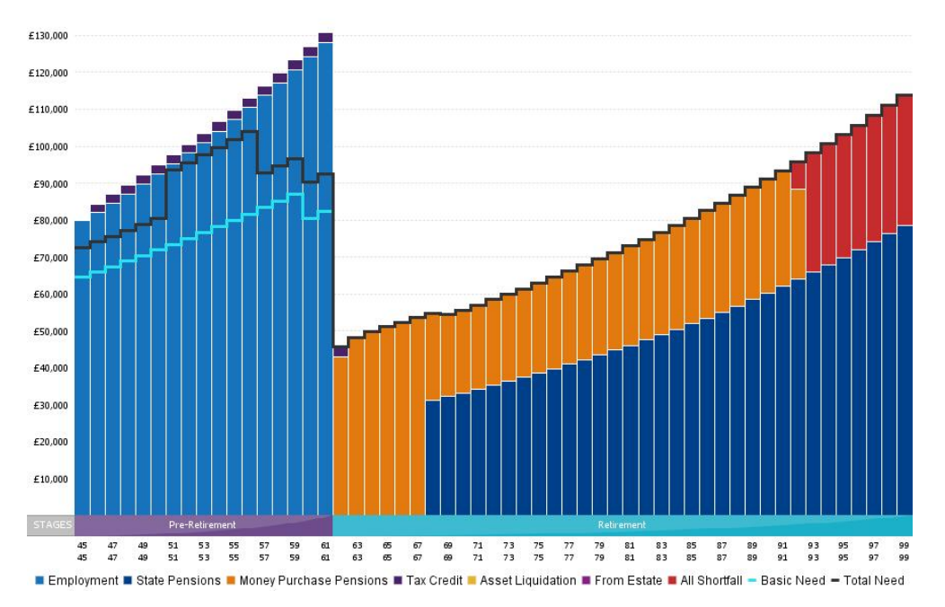

A financial planner will also provide you with advice on accessing your current plans. They’ll take into account things like your risk profile, your tax-position and your objectives to put in place a strategy that works for you.

